DATA SCIENCE TOOLBOX: PYTHON PROGRAMMING

PROJECT REPORT
(Project Semester January-April 2025)

Demographics: An Exploratory Analysis of Census Data

Submitted by

Prabhkirat Singh

Registration No-12309872

Programme and Section- BTECH(CSE) & K23GD
Course Code -INT375
Under the Guidance of
Mrs. Baljinder Kaur

Discipline of CSE/IT


CERTIFICATE

This is to certify that Prabhkirat Singh (student’s name) bearing Registration no. 12309872 has completed INT375 <Course Code> project titled, “Demographics: An Exploratory Analysis of Census Data” under my guidance and supervision. To the best of my knowledge, the present work is the result of his/her original development, effort and study.

Signature and Name of the Supervisor
Designation of the Supervisor
School of Engineering
Lovely Professional University
Phagwara, Punjab.

Date: 13/04/2024

DECLARATION

I, Prabhkirat Singh, student of BTECH (CSE) under CSE/IT Discipline at, Lovely Professional University, Punjab, hereby declare that all the information furnished in this project report is based on my own intensive work and is genuine.

Date: 13/04/2025
Registration No. 12309872

ACKNOWLEDGEMENT

First and foremost, I would like to express my sincere gratitude to my project guide, Mrs. BALJINDER KAUR, for his valuable guidance, continuous support, and encouragement throughout the course of this project. His mentorship has helped me grow academically and personally.
I also extend my thanks to the faculty members and peers at Lovely Professional University for providing an environment that encourages learning and innovation.

TABLE OF CONTENTS
- Introduction
- Source of Dataset
- EDA Process
- Analysis on Dataset
- Conclusion
- Future Scope
- References

1. INTRODUCTION
Exploratory Data Analysis (EDA) is an essential step in any data science project. It helps in understanding the structure of data, detecting patterns, identifying anomalies, and checking assumptions. This project focuses on applying EDA techniques to census demographic data to derive meaningful insights about the population, particularly focusing on rural-urban distribution, birthplace, gender, and age-group statistics.
This analysis provides a visual and statistical summary of the data, which can further support data-driven policy-making and social research.

2. SOURCE OF DATASET
The dataset used in this project is sourced from the Indian Government's Census records, publicly available for research and educational purposes. The data provides district-wise demographic information including total population, gender distribution, rural vs urban classification, and birthplace origin across various age groups.
Dataset Features:
- Table name
- State
- District
- Area Name
- Age-group
- Birth place
- Total Persons, Males, Females
- Rural/Urban segmentation

3. EDA PROCESS
The EDA was conducted using Python and libraries such as Pandas, Matplotlib, Seaborn, and NumPy. The overall EDA workflow includes:
- Data Cleaning: Checking for null values, inconsistent entries, and duplicates.
- Data Transformation: Converting data types, filtering relevant columns.
- Data Aggregation: Grouping data to derive macro-level insights.
- Visualization: Creating various plots to understand distributions, trends, and comparisons.
Key Tools Used:
- Pandas for data manipulation
- Seaborn and Matplotlib for visualization
- NumPy for numerical operations

4. ANALYSIS ON DATASET
4.1 Gender Distribution
i. Introduction
This section analyzes the overall gender distribution across the dataset to understand the proportion of males and females in the population.
ii. General Description
Gender distribution is crucial for planning healthcare, education, and workforce development. Balanced gender ratios indicate social stability, while imbalances may highlight societal issues.
iii. Specific Requirements, Functions, and Formulas
- Columns used: "Total Males", "Total Females"
- Function used: sum()
- Visualization: Donut chart using matplotlib.pyplot.pie() with wedgeprops=dict(width=0.4)
iv. Analysis Results
- The gender ratio is fairly balanced.
- Males slightly outnumber females in the total population.

v. Visualization
A donut chart showing percentages of males and females in the population.
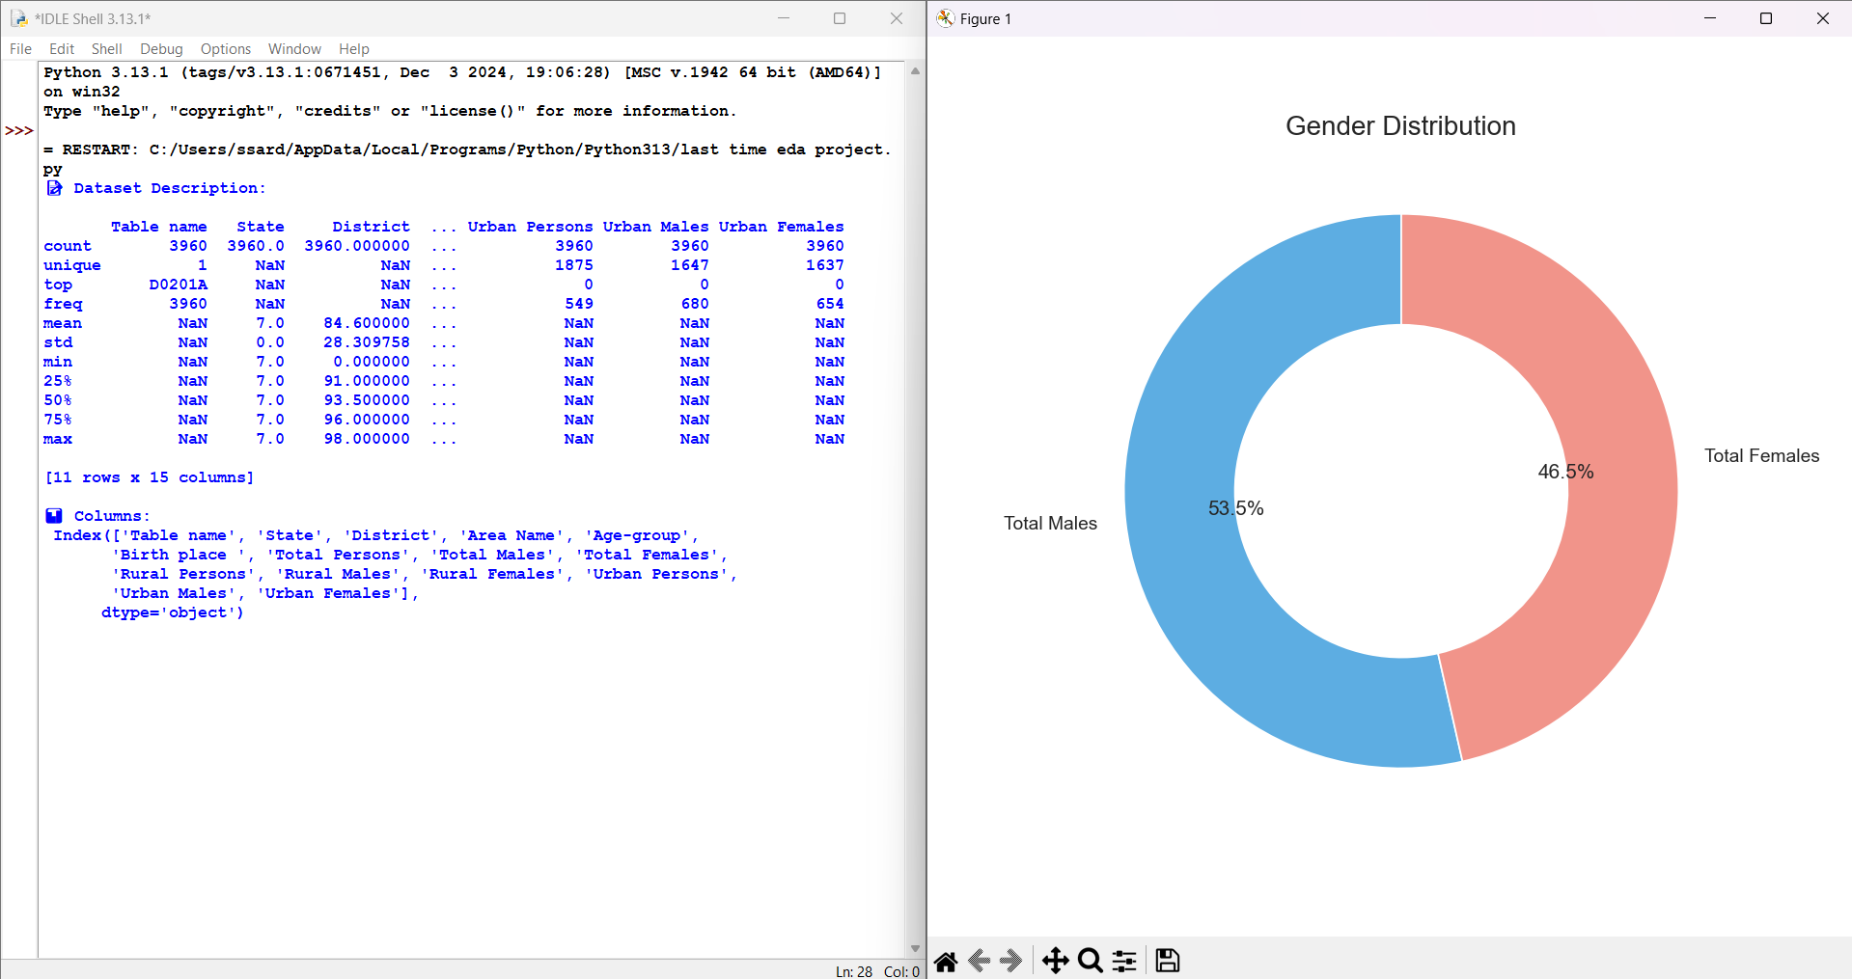

4.2 Urban vs. Rural Population
i. Introduction
This analysis investigates the population spread between urban and rural areas.
ii. General Description
Understanding this distribution helps government bodies in planning infrastructure, utilities, transportation, and policy execution.
iii. Specific Requirements, Functions, and Formulas
- Columns used: "Urban Persons", "Rural Persons"
- Function used: sum()
- Visualizations:
  - Bar plot using seaborn.barplot()
  - Pie chart using matplotlib.pyplot.pie()
iv. Analysis Results
- Rural population exceeds urban in this dataset.
- The difference highlights ongoing urbanization, yet the majority still reside in rural areas.
v. Visualization
Bar and pie charts showing urban vs rural population counts and percentages.

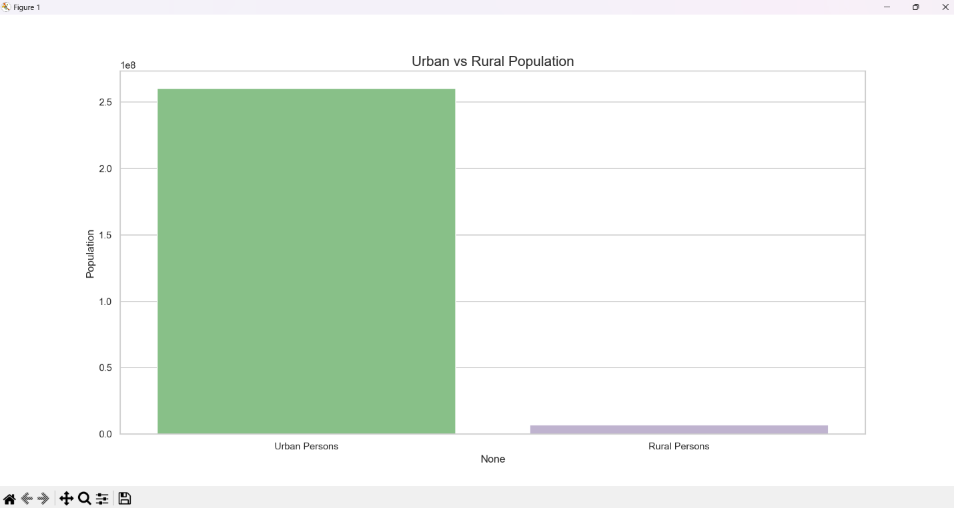

4.3 Top Birthplaces by Population
i. Introduction
This section explores the distribution of population based on their place of birth.
ii. General Description
Analyzing birthplace helps identify migration trends and settlement patterns, useful for state-level planning and migration policies.
iii. Specific Requirements, Functions, and Formulas
- Grouped by: "Birth place "
- Aggregated: groupby() → sum()
- Sorted using: sort_values()
- Top 6 shown using: head(6)
- Visualization: Treemap using squarify.plot()
iv. Analysis Results
- The highest portion of people were born in the place of enumeration or within the state.
- Uttar Pradesh had the highest external contribution in terms of migration.
v. Visualization
A treemap showing top 6 birthplaces and their contribution to population size.

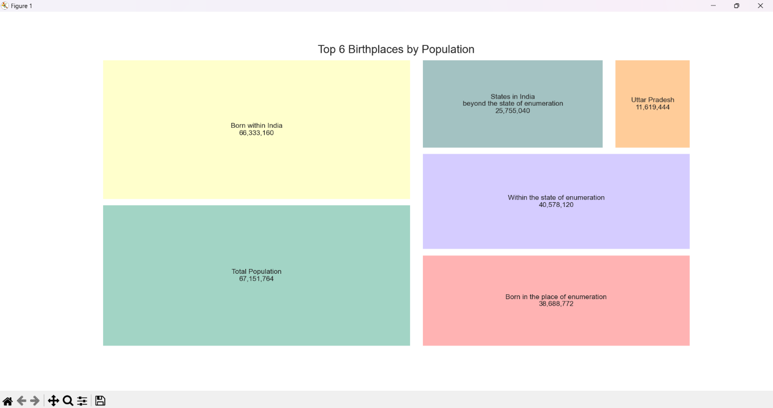

4.4 Age Group Distribution
i. Introduction
This analysis looks into how the population is distributed across various age groups.
ii. General Description
This is essential for planning services like schools, employment programs, and elder care facilities.
iii. Specific Requirements, Functions, and Formulas
- Grouped by: "Age-group"
- Aggregated using: groupby() → sum()
- Visualization: Line plot using seaborn.lineplot()
iv. Analysis Results
- Population is concentrated in working-age groups (15-59).
- A visible dip exists in senior age groups, possibly due to higher mortality.
v. Visualization
A line plot showing trends across all age groups.

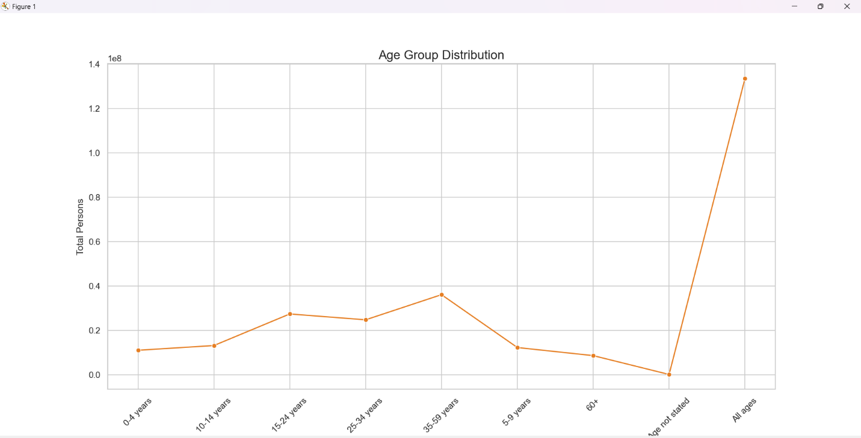

4.5 Correlation Heatmap
i. Introduction
This step identifies how different population metrics correlate with each other.
ii. General Description
Correlations between urban/rural and gender-specific populations can indicate demographic tendencies or biases.
iii. Specific Requirements, Functions, and Formulas
- Columns used:
"Total Persons", "Total Males", "Total Females", "Rural Persons", "Rural Males", "Rural Females", "Urban Persons", "Urban Males", "Urban Females"
- Function: corr()
- Visualization: Heatmap using seaborn.heatmap()
iv. Analysis Results
- Strong positive correlations between total, rural, and urban values.
- Indicates consistency in data structure and mutual dependency between variables.
v. Visualization
A heatmap showing correlation coefficients.
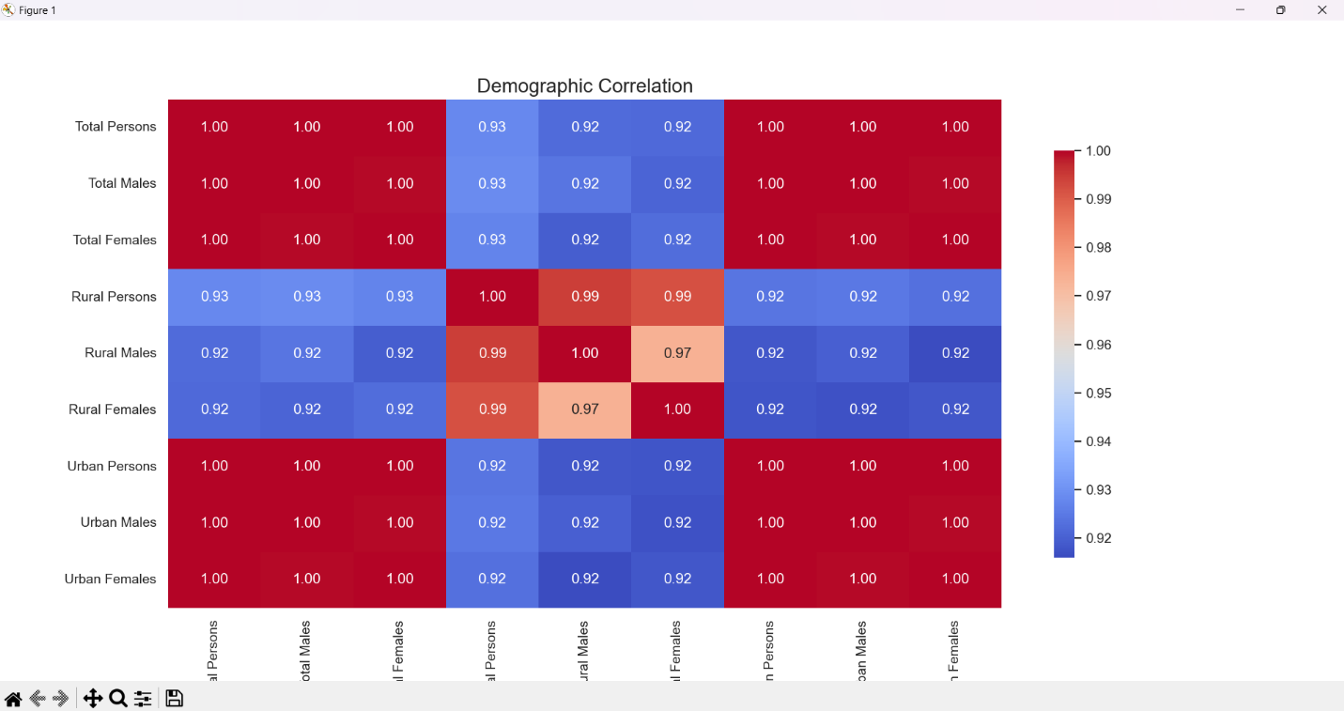
4.6 Population Distribution by Top Birthplaces
i. Introduction
This analysis dives deeper into how total population varies for each top birthplace.
ii. General Description
This helps understand the diversity in population origin and population density patterns.
iii. Specific Requirements, Functions, and Formulas
- Data filtered on top 6 birthplaces
- Visualized using a violin plot with: seaborn.violinplot()
- Y-axis: "Total Persons"
- X-axis: "Birth place "
iv. Analysis Results
- Distribution is skewed in some areas indicating uneven contributions from certain birthplaces.
- Some birthplaces (like UP) show a wider spread.
v. Visualization
A violin plot showing the distribution of population values per top birthplace.
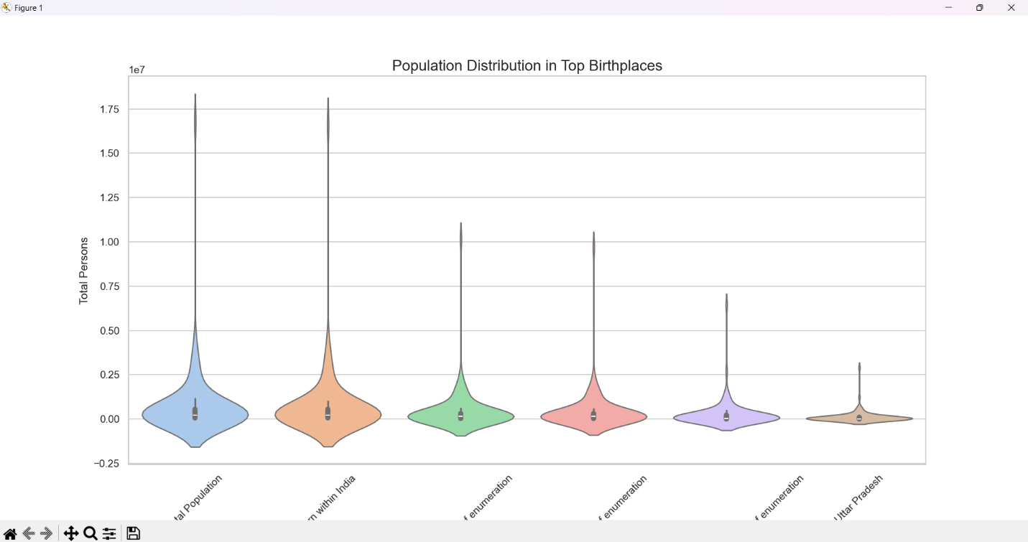

5. CONCLUSION
The EDA revealed significant trends in population distribution, gender balance, and birthplace demographics. Urbanization is prominent in certain districts while rural areas still dominate a significant portion. The age-group analysis can assist government agencies in policy formulation.
This project reinforces the importance of EDA as a foundational step in the data science pipeline. It not only cleanses the data but also reveals meaningful stories hidden within.

6. FUTURE SCOPE
- Predictive Modeling: Future projects can use this data to build predictive models for urban growth or resource demand.
- Geospatial Analysis: Mapping demographic trends on geographical maps using tools like GeoPandas.
- Integration: Combine with socio-economic data for deeper insights.
- Interactive Dashboards: Creating dashboards using Plotly or Tableau for dynamic data exploration.
- Time-Series Forecasting: Incorporating temporal data to forecast population trends and migration patterns.
- Clustering and Classification: Applying unsupervised and supervised learning techniques to identify population clusters and categorize demographic segments.

7. REFERENCES
[1] Government of India Census Dataset, https://censusindia.gov.in/nada/index.php/catalog/10717
[2] https://seaborn.pydata.org
[3] https://matplotlib.org
[4] https://pandas.pydata.org
[5] https://github.com/PrabhkiratSingh123/EDA-PROJECT-RELATED-TO-Demographics-An-Exploratory-Analysis-of-Census-Data
[6] https://www.linkedin.com/posts/prabh123_datavisualization-surveys-csvdataanalysis-activity-7316518144338997250-VhTP?utm_source=share&utm_medium=member_desktop&rcm=ACoAAEfmTF8B_Vu9pQQ-Ku2UjdyqqKo-AoXitLs

